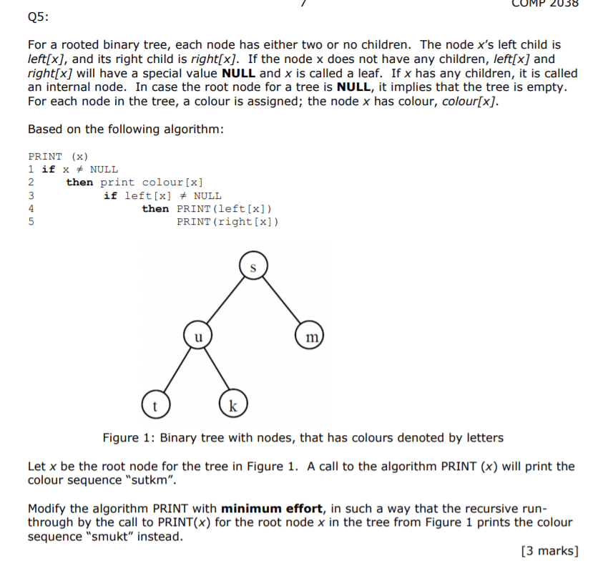

Answer

Initial Algorithm:

Print (x)

If x != NULL  
 **Then** print colour[x]  
 If left[x] != NULL  
 **Then** print(left[x])  
 Print(right[x])

We need to slightly modify the exploring order. Instead of first exploring left, we should first explore in the right. So, **the pseudocode would be the following**:

If x != NULL  
 **Then** print colour[x]  
 If right[x] != NULL  
 **Then** print(right [x])  
 Print(left[x])

* In terms of time complexity, the overall Big-O would be O(n) – number of edges.